Prompt.It Submission
AI Game Development
By Prashant (prashant.prashant@chubb.com)
Game: Hop.It
A vertical platformer game for Windows featuring both single-player and thrilling 1v1 online battles. Challenge your friends in a race to survive and climb higher—whoever stays alive longer with the highest score wins!
AI Tools:
- Cursor AI (Code gen)
- ChatGPT & Leonardo AI (Game assets & images)
- SunoAI (Background music)
Prompt History for Graphics creation | Prompt History for Game Idea and Help
Prompt:
Create a platformer game where the character continuously jumps without player input. The core mechanics should be:
- The player character (a sanding rectangle) automatically jumps upward at a constant rate.
- The player can only control the character's horizontal movement (left/right).
- Horizontal platforms must get spawned at random location above the player, at specific height difference.
- New platforms should generate above as the player ascends.
- The game ends if the player falls below the bottom of the screen. Then player can restart after pressing space
- Score increases based on height reached, with high scores saved between sessions in local text file.
Technical specs:
- Use pygame for the implementation
- Use screen: 400x600 pixels (4:6)

Include these components:
- Player class that handles automatic jumping and horizontal movement
- Platform class to use while generating platforms.
- Score system that displays the player's score based on height he reached
- High score persistence between game sessions
- Background that scrolls continuously

First Draft
Had errors loading the game, then few jumping anomalies without collision detection
Prompts to fix the errors:
- The player is not jumping properly with an accelerated jumping pattern, it should slowdown on max height then accelerated when coming back o ground.
- The platforms must have a collision detection to catch the jumping character.
Initial app (after few error fixing prompts):
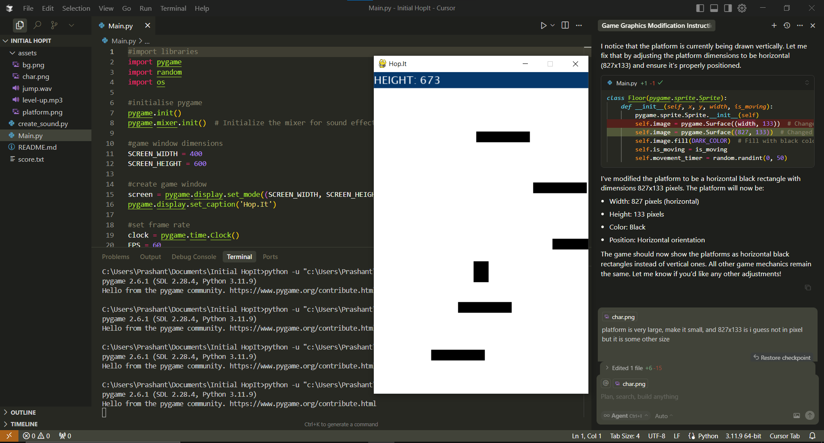
The horizontal rectangle is the platform
Vertical rectangle is the player that jumps continuously
Graphics
Generating custom self-character using ChatGPT:
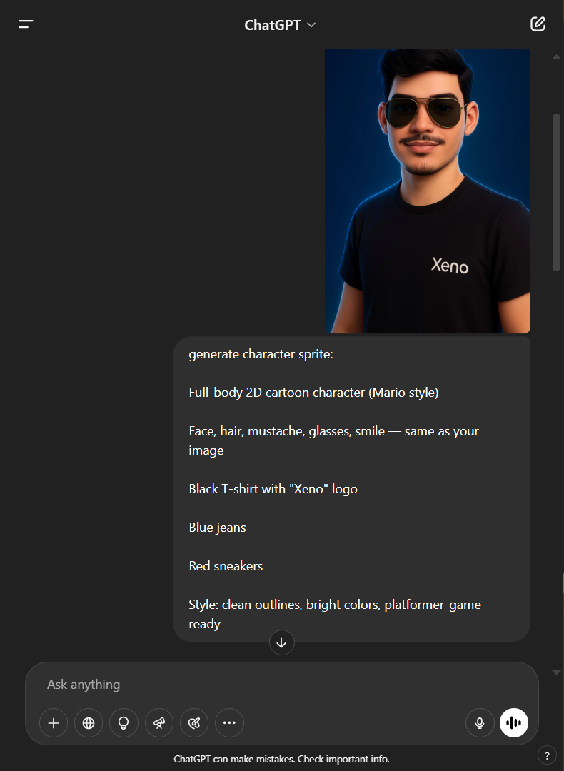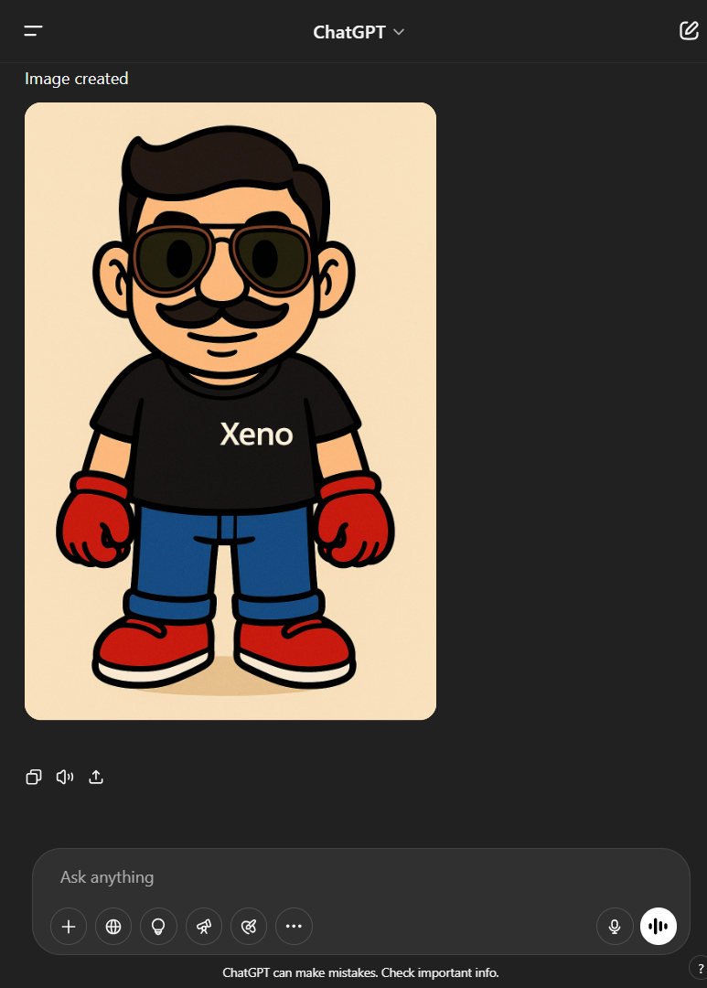
Prompt: “generate character sprite: Full-body 2D cartoon character (Mario style)
Face, hair, mustache, glasses, smile — same as the image, Black T-shirt with "Xeno" logo
Blue jeans, Red sneakers. Style: clean outlines, bright colors, platformer-game-ready”

Character Sprites (for animation)
Prompt: “Make character sprite of this character for jumping only facing the player
While jumping it should have 5-6 movements for smooth animation starting from lifting his hand a bit and bending his knees for the jump, and similarly the other animations the initial and final position of the character before and after jump should be same as typical character sprite”
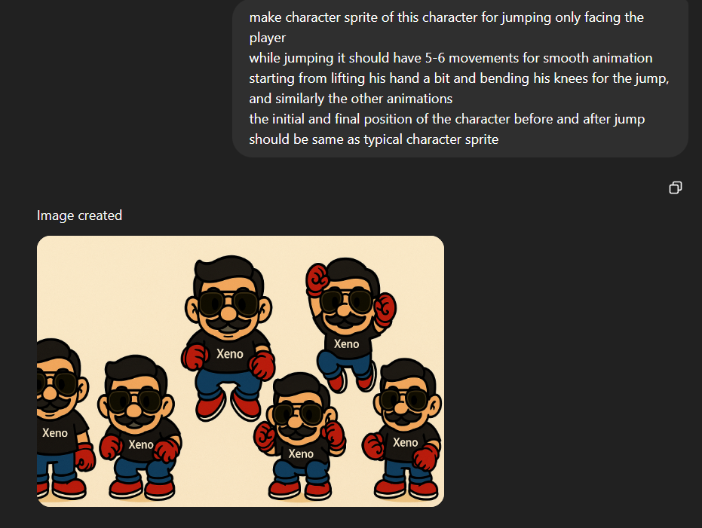

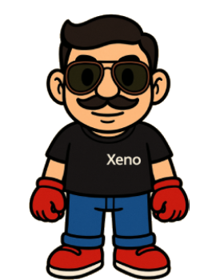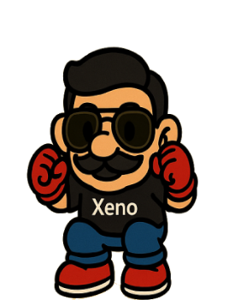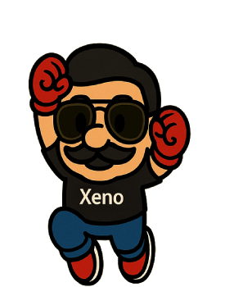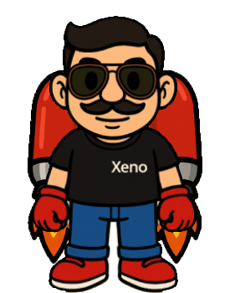
Jetpack Prompt: “make the character wear this jetpack on his back, facing front”
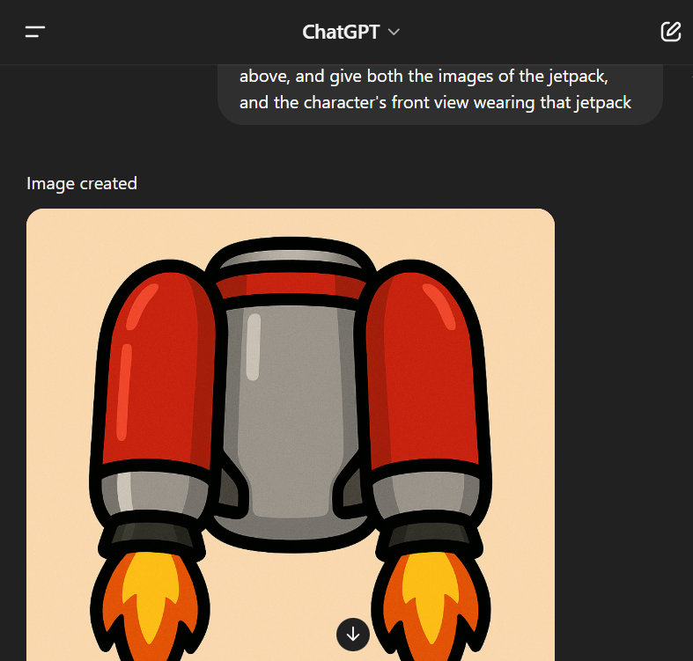 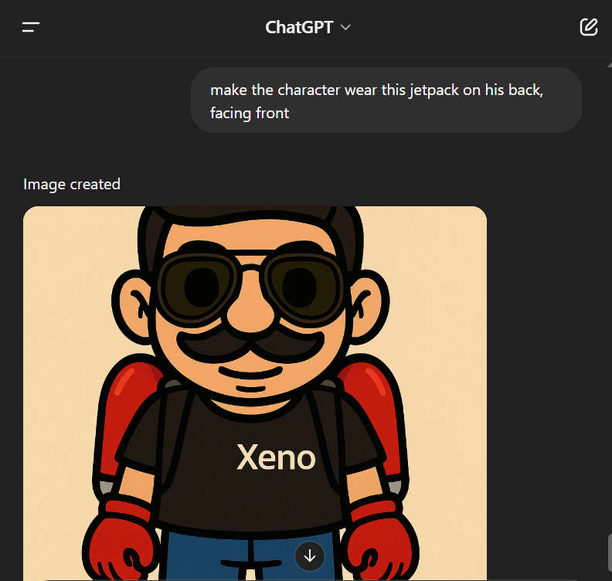
jet.png jet-char.png
Prompt: “create a small jetpack for the main game character above, and give both the images of the jetpack, and the character's front view wearing that jetpack”
Repeating Background image
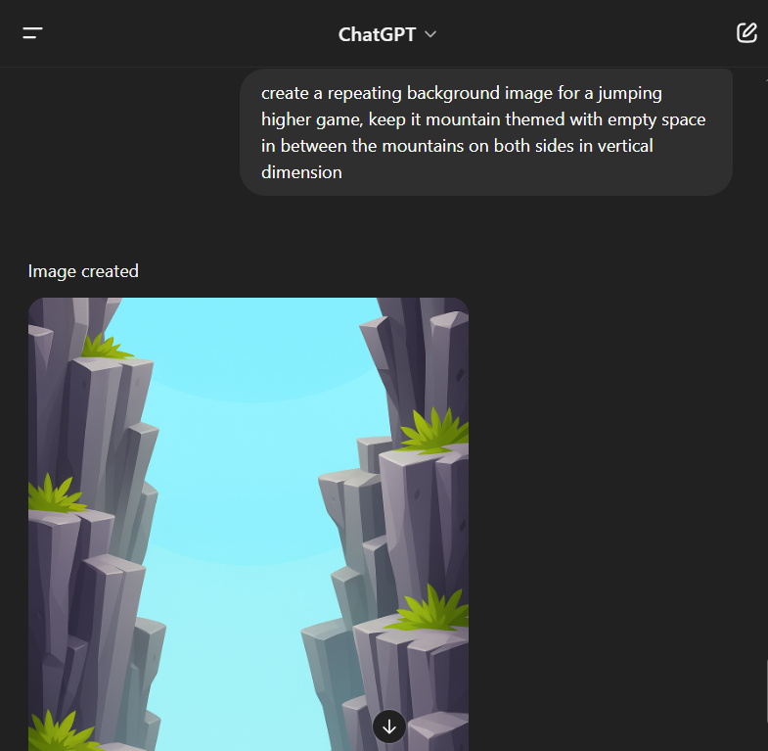
“create a repeating background image for a jumping higher game, keep it mountain themed with empty space in between the mountains on both sides in vertical dimension”

Using Leonardo AI
Prompt: “Make long retro game 2d rectangle shaped cartoon platform asset with grass covering at the top on a soil type structure”
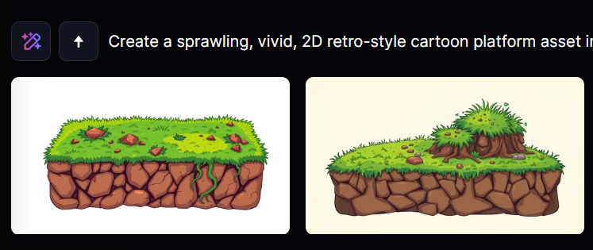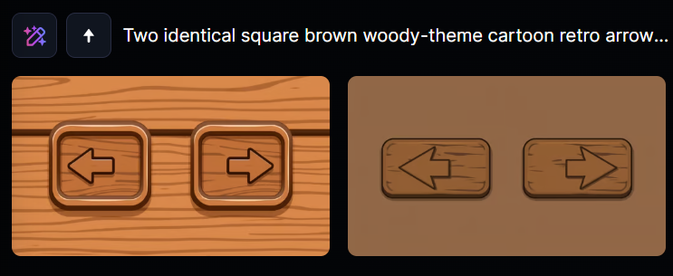
“generate two square brown woody-theme cartoon retro style left and right arrow button for game”
Sound effect (Eleven Labs)
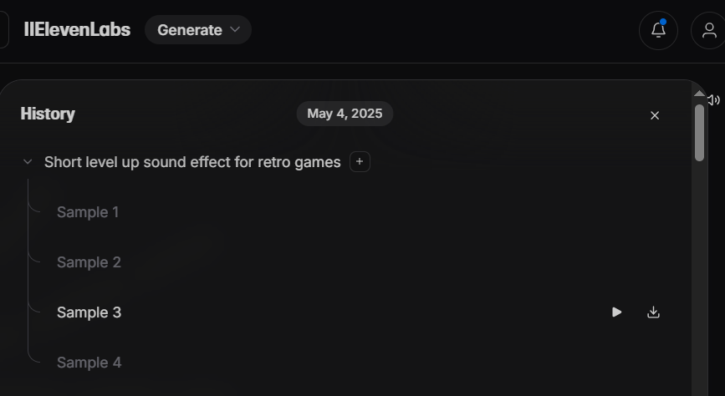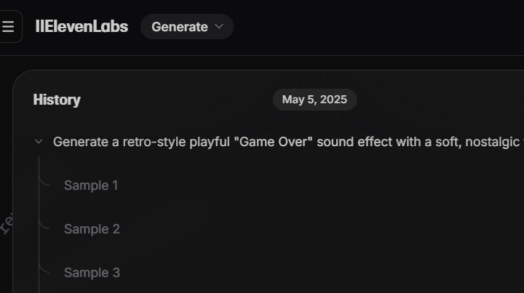
Level up sound effect Game over sound effect
Background music (SunoAI link):
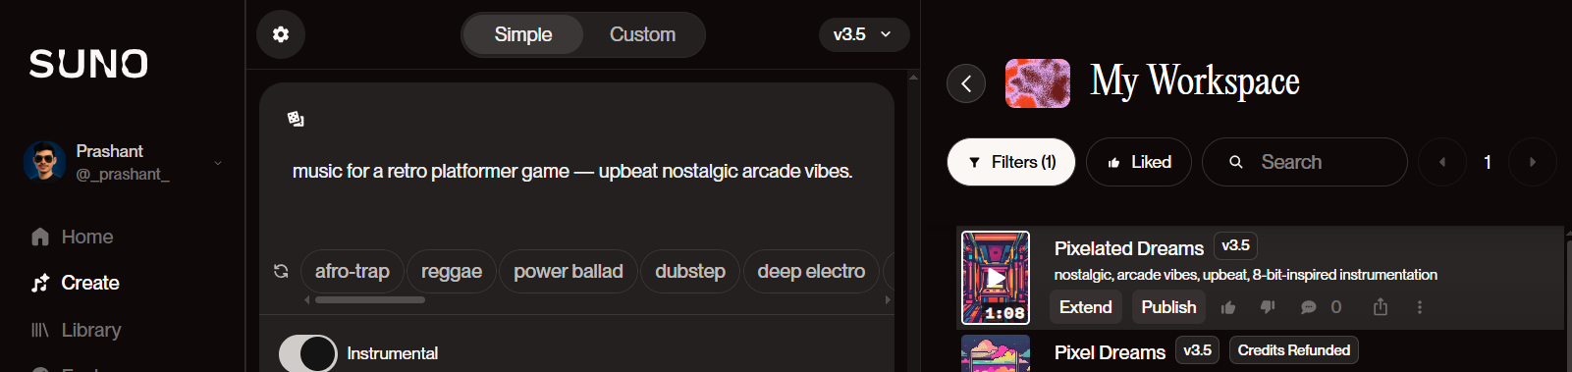
Prompts to enhance it after basic implementation:
- Replace the character rectangle with an image name “char.png”, platform rectangle with an image “platform.png”, background with image name ”bg.png” from the @assets folder
- Play level-up.mp3 sound effect when high score is crossed.
- Play bg-music.mp3 in the background, it should stop when game overs.
- Introduce moving platforms at higher scores (e.g. above 500 points) with random speeds
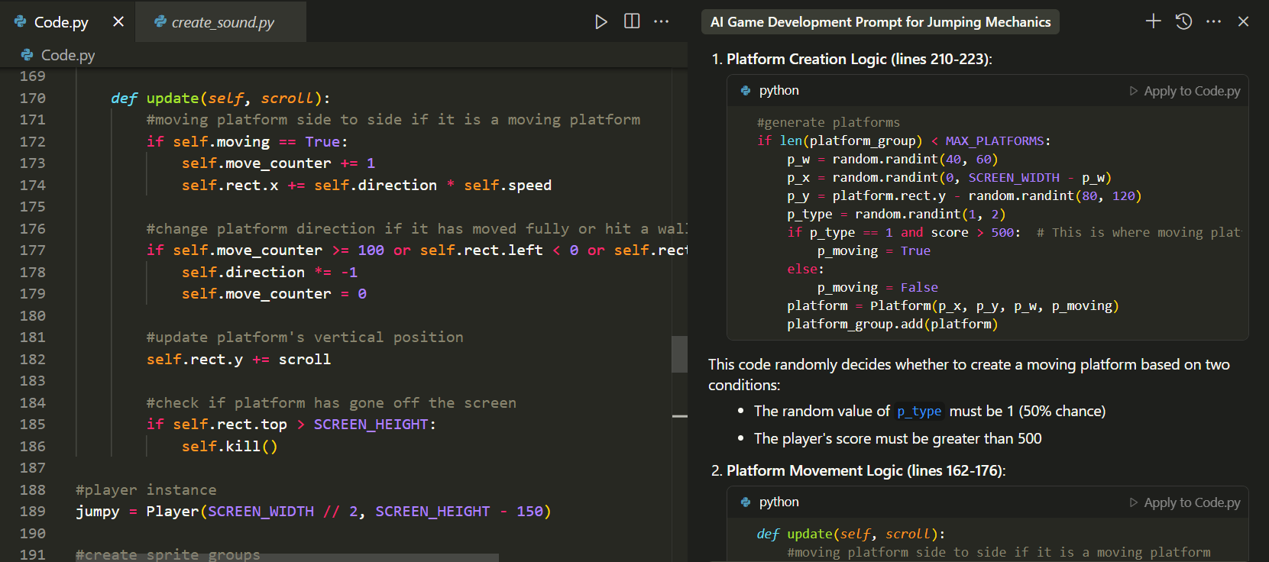
- Map the character’s movement to left/right arrow buttons correctly..
- At the start, show short message stating to use Arrow keys on the keyboard to play the game
- The screen must scroll upward as the player ascends
- If high score is reached, then write "New High Score" when game overs along with other text.


Solving bugs and anomalies:
“Make sure if previous platform is moving then the next one should be static.
align all the text on the game over screen properly, for an even padding with center aligned
Decrease speed of moving platforms, Increase sensitivity of on-screen buttons”

Adding jetpack power-up
“after every 500 pts, place the jet.png in area between the platforms, so that the player can jump and take it
when player takes the jet, it changes to jet-char.png and goes higher up crossing over 5 platforms, then changes back to its normal animation”
“Play level up.mp3 sound effect when player takes the jetpack”
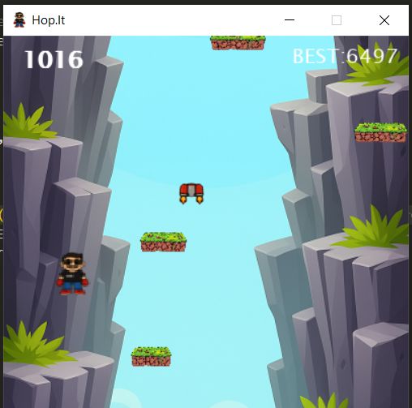

Animating
“instead of static character "char.png" animate the player using the character sprites: jump1, jump2, jump3.png The animation shows the following sequence of png images while the player jumps and land:
Going up:
jump1, jump2, jump3

Dropping down:
jump3, jump2, jump1”
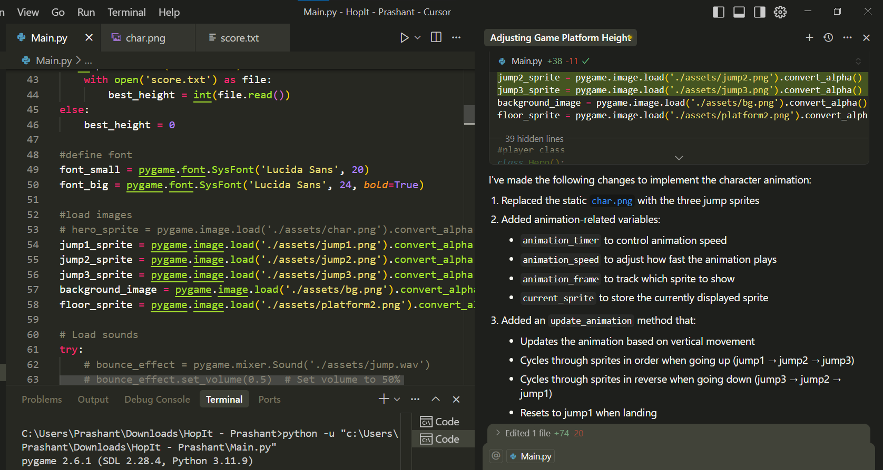

Adding on-screen left/right buttons:
“the buttons are very small make them large, “Game Over" font should be large and bold
Add functionality when button is press and hold, the player should go left/right with the same sensitivity as it is done when the left/right key is pressed and hold, to adapt this to touch screen events (finger motion) for mobile platforms using FINGERMOTION?”
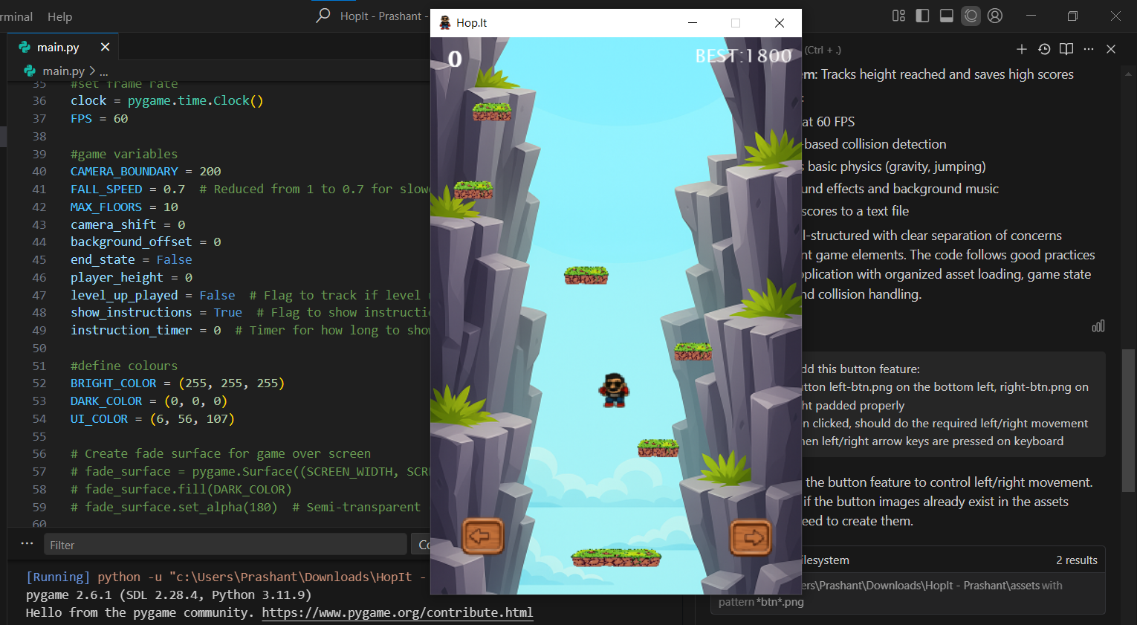
Adding Home screen
On cursor:
“add the auto scrolling on home page only, while playing, the background should scroll as per player's movement same as before”
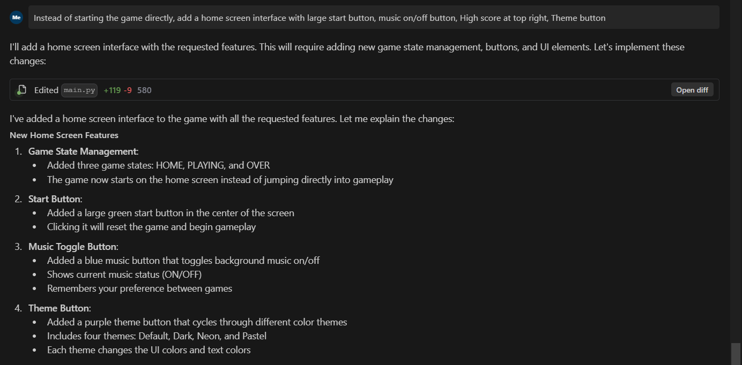

ChatGPT Asset generation Prompt: “generate buttons for "START", icon button for Music(🎵), SFX(🔊), Theme(Day/Night toggle) in the same theme”
“Create icon for my game to be displayed on the home screen with Hop.It written on it It should suit the mountain and greenery background with these wooden theme buttons surrounded by some climber plants”
“Generate the clouds png in 400x600, having the design same as attached background image’s cloud”
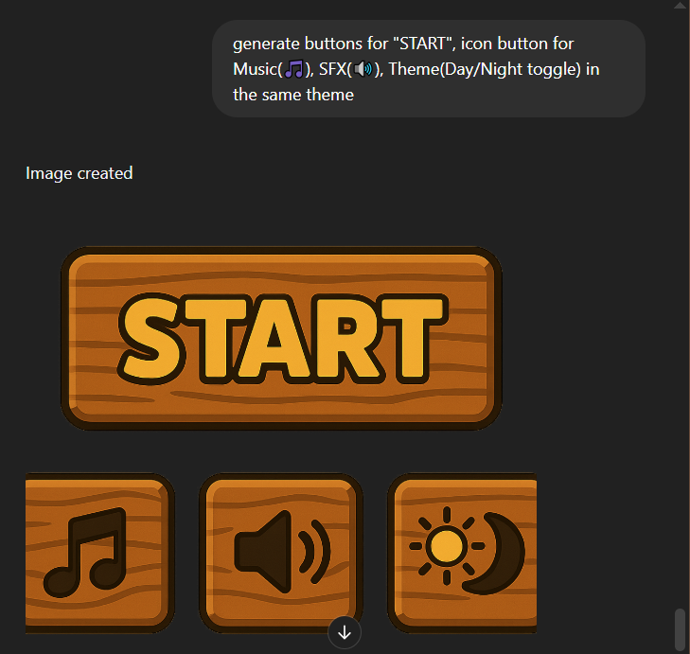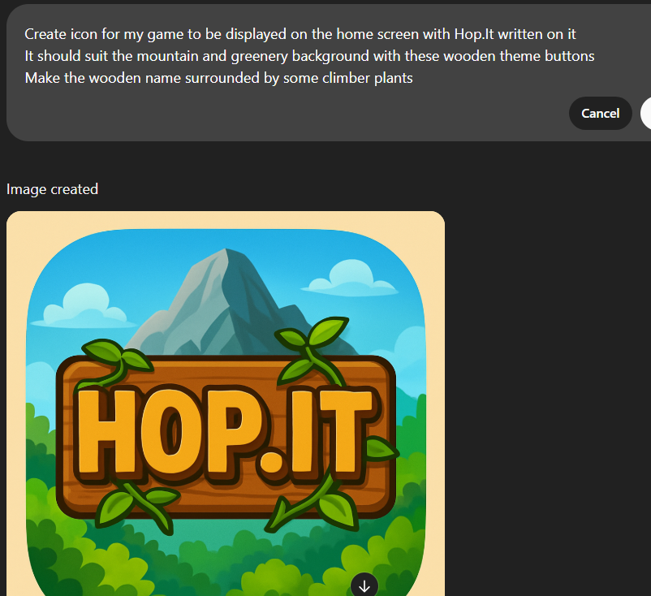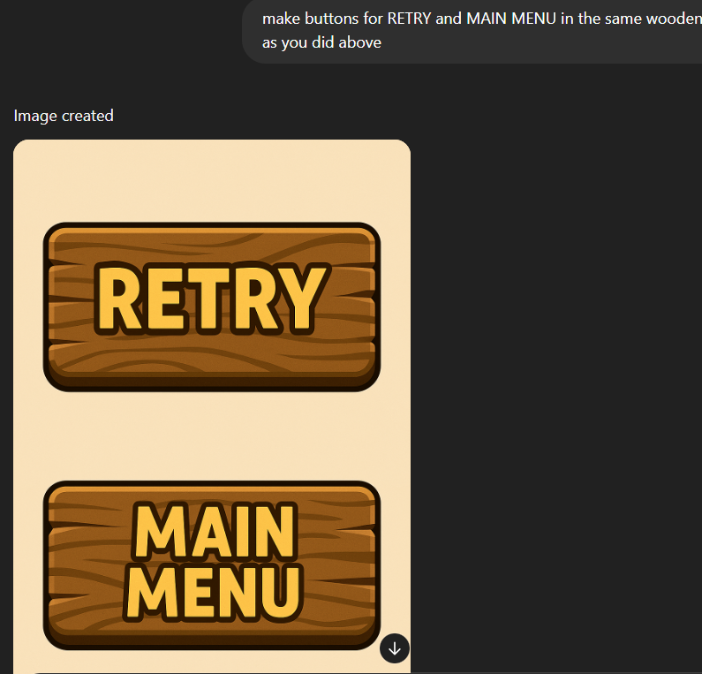

Cursor Prompt: “Instead of rectangles, use images for the Start, Music, SFX, Theme button from @assets same As the layout in the attached image, for the music, SFX button, when they are turned off, replace the image with musicoff.png and sfxoff.png and fix the logic for all the three buttons to work correctly”
“after game overs, display game over screen: it should display Retry and Main menu, use the images retry.png and main-menu.png for it, implement animation as we did for theme button.
set bg color to hex a1eff3 or rgb(161, 239, 243)”
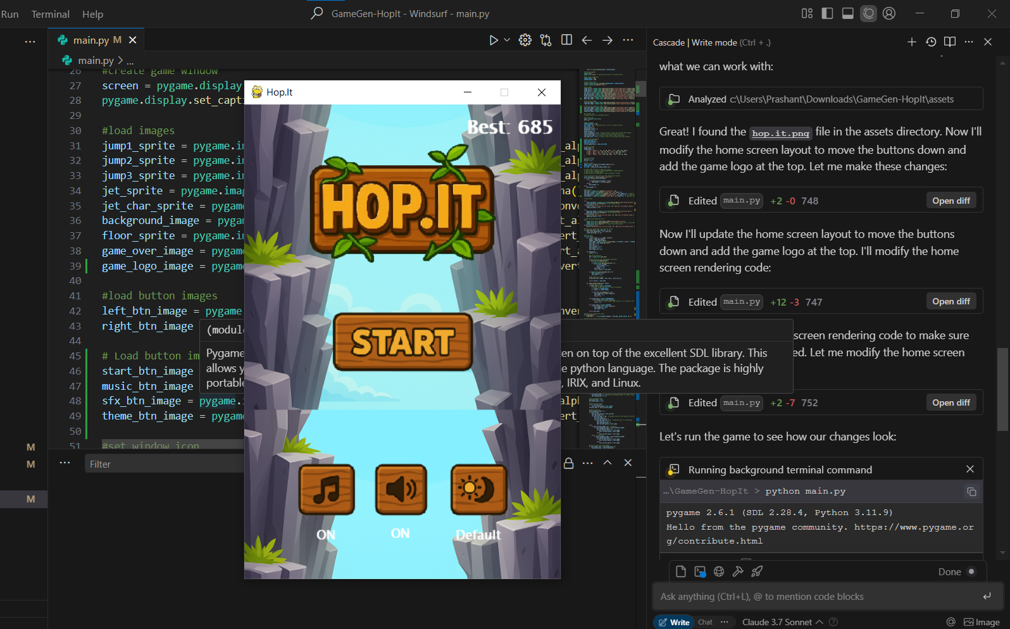

Adding animation on home screen:
Prompt : “add animation on the home screen, when It appears, the HOP.IT png, add pop animation to the start button that drops from top one after the other to their position. and the lower 3 buttons appear from the bottom one after the other in animated style”

Fixing errors
Prompt: “the button disappears and reappears when clicked, make it reappear.
also the sound effects button is not working correctly, sometimes it does not turn off after click”
“even if the sfx is turned off, the level-up music plays while playing the game fix it
also, when game ends and main menu is pressed, the start button appears thn dissapears then comes with aniation, but it should not be there by default, fix it”
“Fix the error: music_button = Button(row_start_x, row_y, music_btn_image, button_scale, music_off_btn_image)
^^^^^^^^^^^^^^^^^^^^^^^^^^^^^^^^^^^^^^^^^^^^^^^^^^^^^^^^^^^^^^^^^^^^^^^^^^^^^^
TypeError: Button.__init__() takes 5 positional arguments but 6 were given”

Designing font:
Prompt: “I want to write text as: bold, cartoonish, and slightly rounded sans-serif font. with thick black outline like Arial Black, the letters to be golden yellow to look like playful, often seen in games or children's applications.”

Making it Online-Two Player game
Idea: To make two players compete in an online common room/session using a room code.
- The first player types a room code (e.g., "XY123") — this creates the room on the server.
- The second player must enter the same code to join that specific room.

ChatGPT Prompt: “How can we implement the online feature:
Where players Can challenge each other live
Suppose A challenges B: on A's screen- B's score is visible
on B's screen- A's score is visible. Whoever falls first loses, and win/lose msg appears on respective player's screen and round ends. Give small code for server, player A and B And steps to make the server live on a free service for this so that it should be up and running always, so that I don’t have to start the server manually every time”
Response:




Prompt: “Modify it such that: Each room can only have 2 players.
Extra connections are rejected if the room is full.
Timeout option: if a room has only one player for too long, you can optionally disconnect them (write but comment it out for now).”
Modify the code so that as soon as the other player joins, client gets to know that another player joined so that we can write appropriate check in game to start relaying the live score, alive and startgame data from client A to B.
Find the code in this repo: https://github.com/prashantzzz/Hop.It-Server

Visualization of the server implementation using chatgpt:
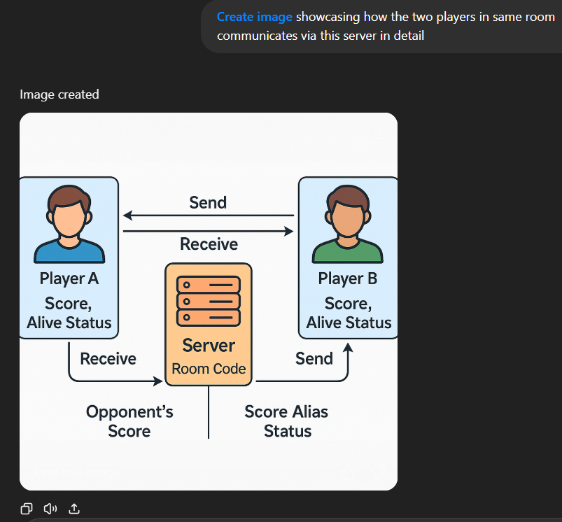

Deploying on render.com
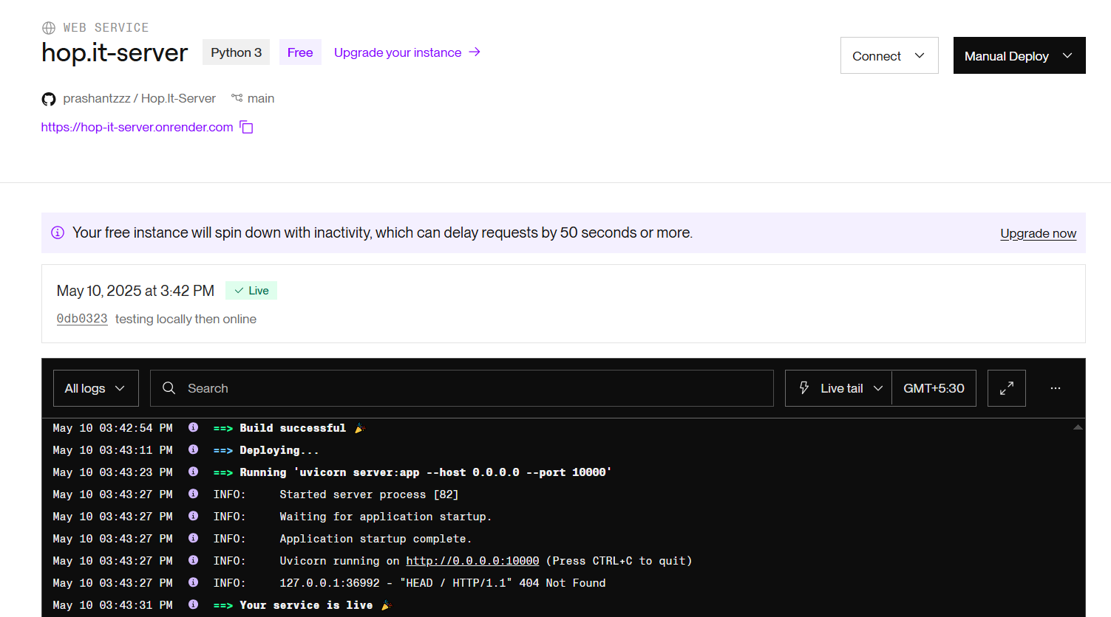
Since we are ready with the server individually, lets integrate the client code in the game.
Prompt: “Now I want to implement online feature to this game,make every step precisely for it. Where players Can challenge each other live in a common online room.
Suppose A challenges B by creating a room and both join the room: then when the game sarts, on A's screen- B's score is visible AND on B's screen- A's score is visible. Whoever falls first loses, and win/lose msg appears on respective player's screen and round ends. and room closes.
@server.py @client.py is the working code for server and client, which is hosted on render and working correctly. score and alive status will be sent by the players in the room to be in sync for live score display on each other's screen.Implement this in our game considering all the points carefully”
Response:
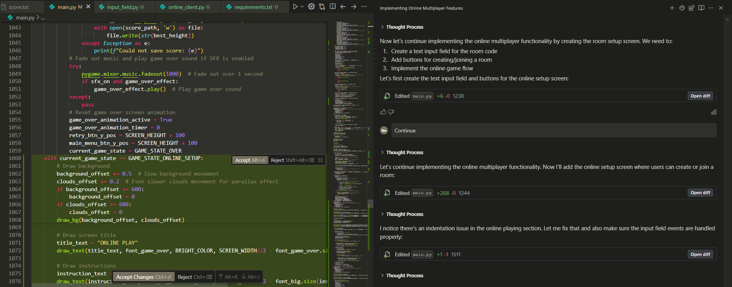
Prompt: “after I generate a code and hit play in one game window, and enter the same code in another game window: both the screen shows waiting for opponent and nothing happens after that.
what should happen: after entering the code if another player joins the room, then for both the players the screen should display that another player has joined. And after both join, there should appear a start button, clicking which, the should start on both devices with displaying live score and alive status.
Remember that if you want to change the server.py code then ask me as I’ve hosted it on another platform”

Error fix:
“it still writes 'waiting for opponent' and nothings happens after that”
sometimes, game is not able to reach the server and error comes: Connecting to wss://hop-it-server.onrender.com/ws/90365... Failed to connect to room: server rejected WebSocket connection: HTTP 502
handle this and show on the client screen after this error is caught and make them return to home screen
don’t affect any other functionality”
“it should only display the msg and start button if both players join, server returns a msg ‘OPPONENT_JOINED’ when the second player joins the room.
And handle the case when a room is full, display that on the Room code enter screen just below the Input box, the server returns 'ROOM_FULL' message in that case”
“opponent score is showing zero on the game over screen in the online mode make minimal change to fix it”

Resultant screenshot:
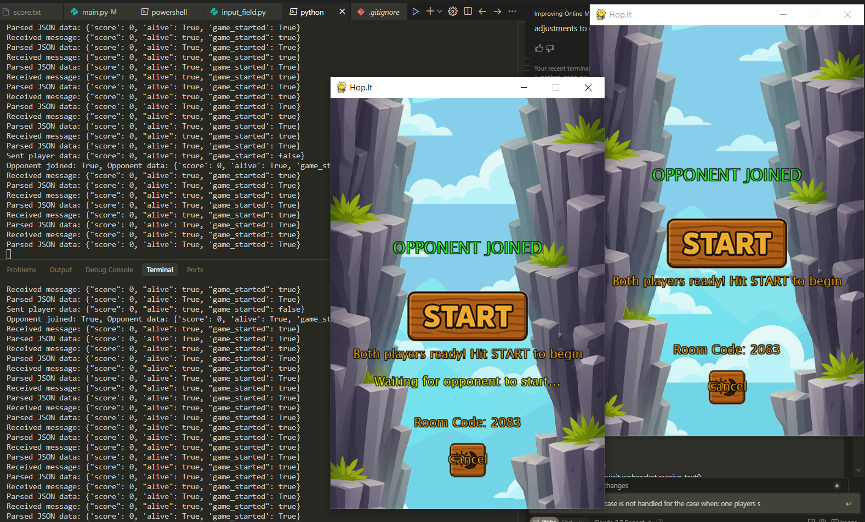
When both players join the room (see logs for game stared status)

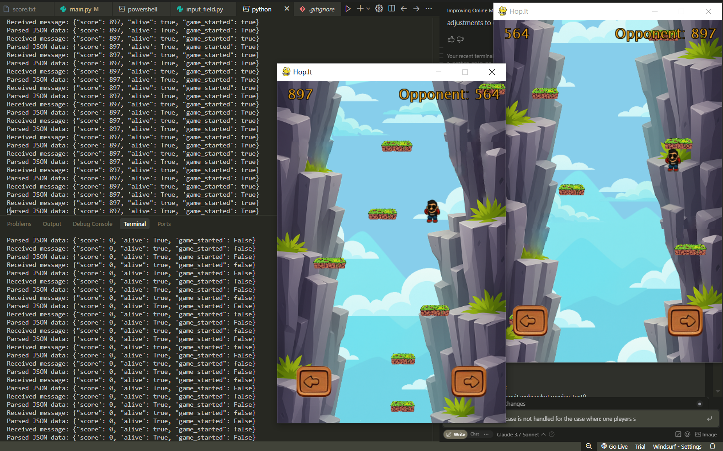
When both players start playing (see logs for live score sync)

Generating graphics for online mode (ChatGPT):
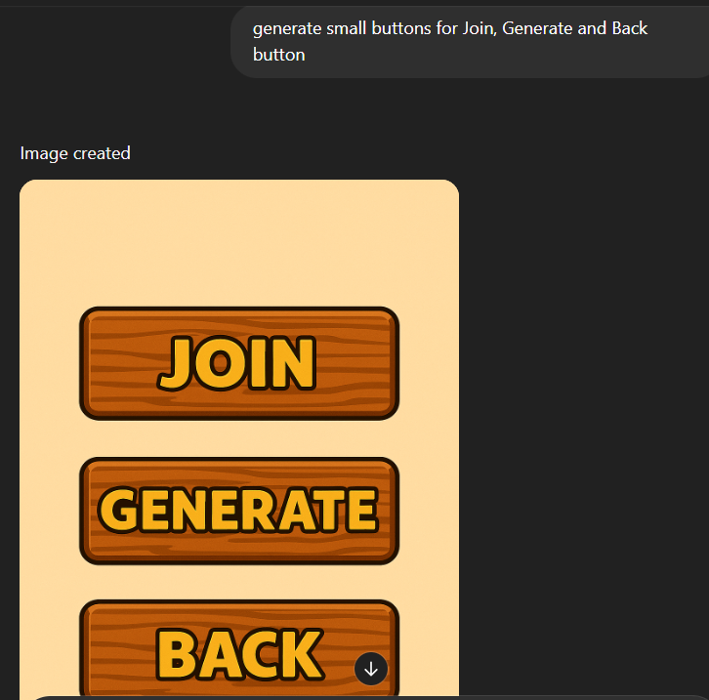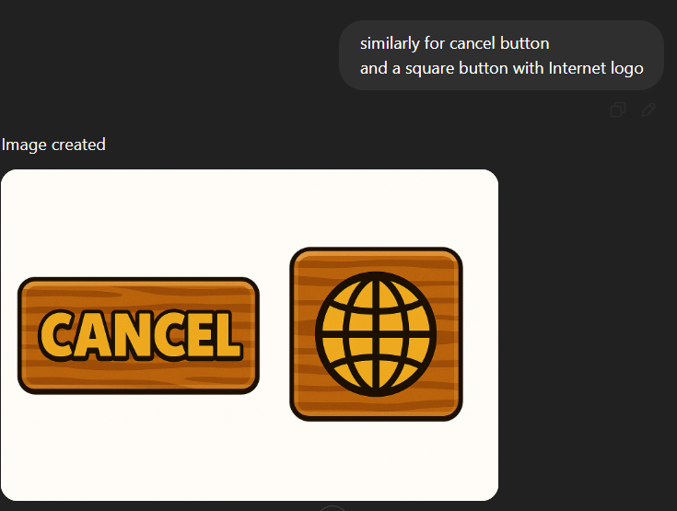

Cursor Prompt:
“for the buttons: cancel, back, generate, join, online button-> instead of theme button or writing text, use the respective images from @assets folder”
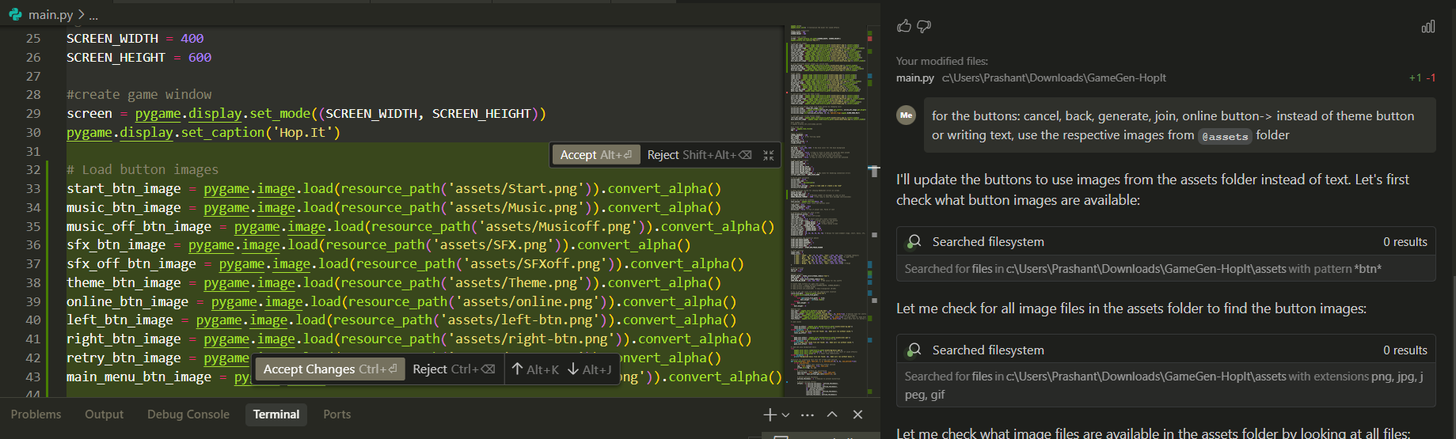

Deciding winner and loser
ChatGPT Prompt: “Generate test cases for the two players in the room after the game starts, and tell which once should be the winner with best suitable and fair gameplay regulations For example:
1)Player A height > player B and B falls down. 2) Player A height > player B and A falls down 3) ...so on”
Response:
Test Case | Player A | Player B | Outcome | Winner Reason
1 | Height = 150, Alive = True | Height = 120, Alive = False | A wins | B fell first
2 | Height = 150, Alive = False | Height = 120, Alive = True | B wins | A fell first
3 | Height = 150, Alive = False | Height = 120, Alive = False | A wins | Both fell, A had higher height
4 | Height = any, Alive = True | Height = any, Alive = True | Game Continues | No one has fallen yet
5 | Height = 120, Alive = False | Height = 150, Alive = False | B wins | Both fell, B had higher score
6 | Height = 120, Alive = True | Height = 150, Alive = False | A wins | A survived
7 | Height = 150, Alive = False | Height = 120, Alive = True | B wins | A fell first
8 | Height = 150, Alive = False | Height = 150, Alive = False | Draw | Both fell at same score
9 | Height = 200, Alive = True | Height = 200, Alive = False | A wins | A survived
10 | Height = 200, Alive = False | Height = 200, Alive = False | Draw | Equal score at same fall time

Cursor Prompt: “
For the win and lose logic, ensure you are following the attached test cases properly, see whose score is more or less then the corresponding winner and looser and implement it in the code to decide the winner/loser or Draw match after the game overs in the online mode, before disconnecting from the room, also when following error occurs: Connecting to wss://hop-it-server.onrender.com/ws/5728... Failed to connect to room: timed out during opening handshake”

Error fix prompt:
“opponent score is showing zero, fix it without affecting any other things”
“after the You Win message appears, the window becomes not responding but on the you lose client, the window stays active and works fine”
“when I click the retry or menu button, the button that is placed on the next screen at that position also get pressed, so one click presses 2 buttons. fix this so that one click is taken by the upper button only, not any other button”

Finally, I converted the game into .exe using auto-py-to-exe (built on top of pyinstaller) to run full featured game on any windows device. And used pygbag with itch.io to host offline version on web.
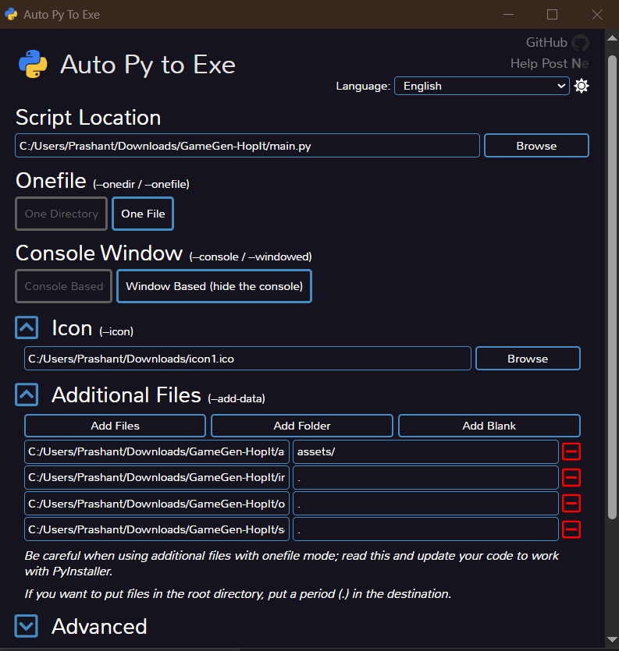 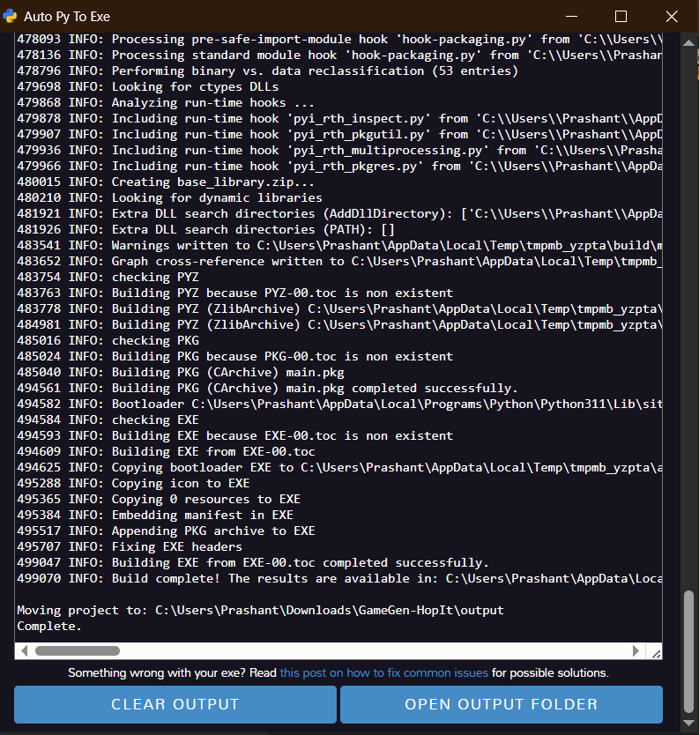
Pyinstaller command used:
pyinstaller --noconfirm --onefile --windowed --icon "C:\Users\Prashant\Downloads\icon1.ico" --add-data "C:\Users\Prashant\Downloads\GameGen-HopIt\assets;assets/" --add-data "C:\Users\Prashant\Downloads\GameGen-HopIt\input_field.py;." --add-data "C:\Users\Prashant\Downloads\GameGen-HopIt\online_client.py;." --add-data "C:\Users\Prashant\Downloads\GameGen-HopIt\score.txt;." --hidden-import "asyncio" --hidden-import "websockets" --hidden-import "pygame" --hidden-import "websockets.legacy.client" --hidden-import "websockets.legacy.protocol" "C:\Users\Prashant\Downloads\GameGen-HopIt\main.py"
The executable is available in the drive link as and in the release of the git repo.

